AWS -CHALLENGES
Key Management service
Create a Key in AWS Console
Step 1: Create KMS Key
- Go to AWS Console → KMS
- Click Create key
- Select Symmetric
- Usage: Encrypt and decrypt
- Alias: s3-encryption-key
- Add alias (example: alias/my-app)
Assign key administrators and users
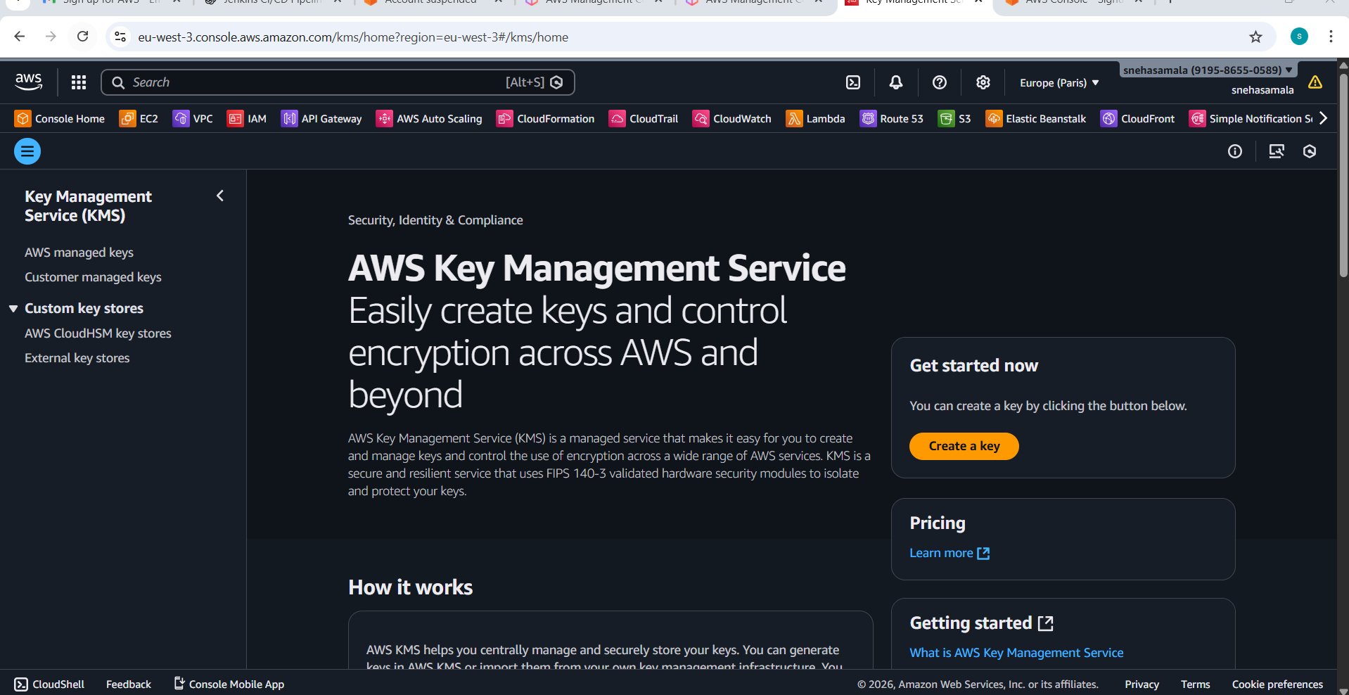
- Configure the key
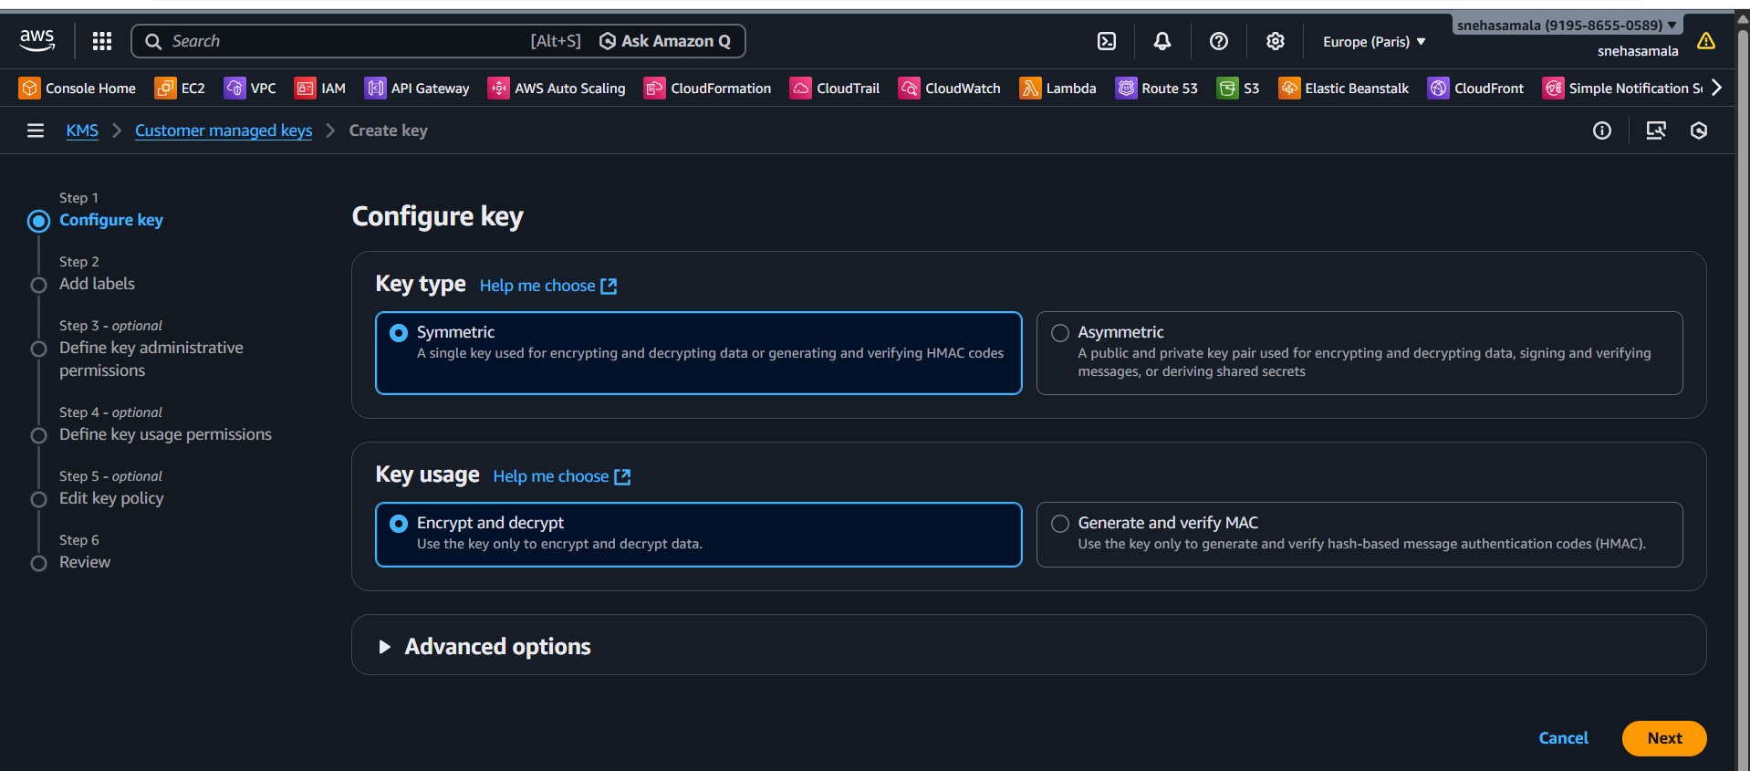
- Add the lables
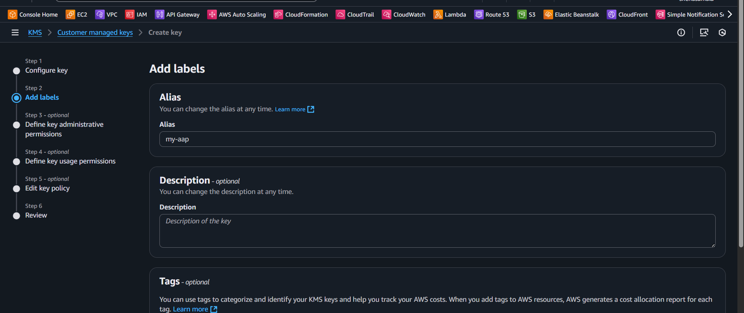
- Define key administrative
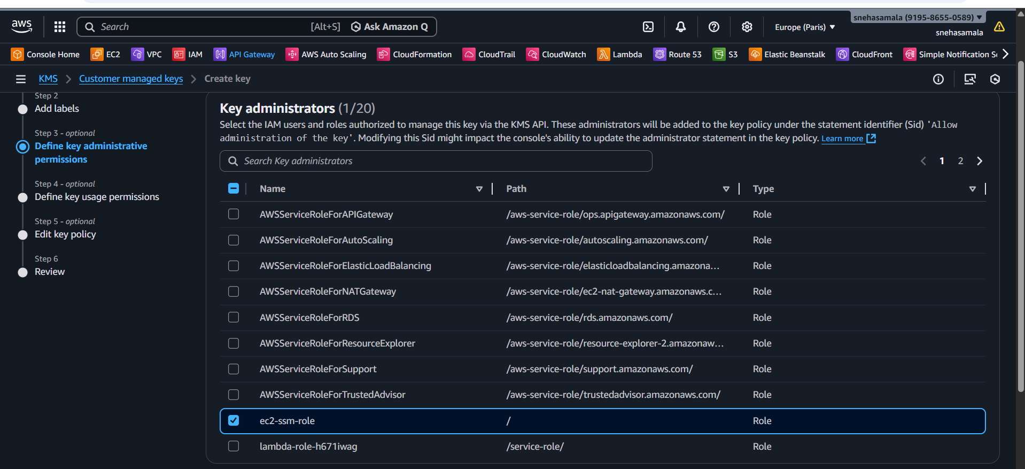
- Add permissions
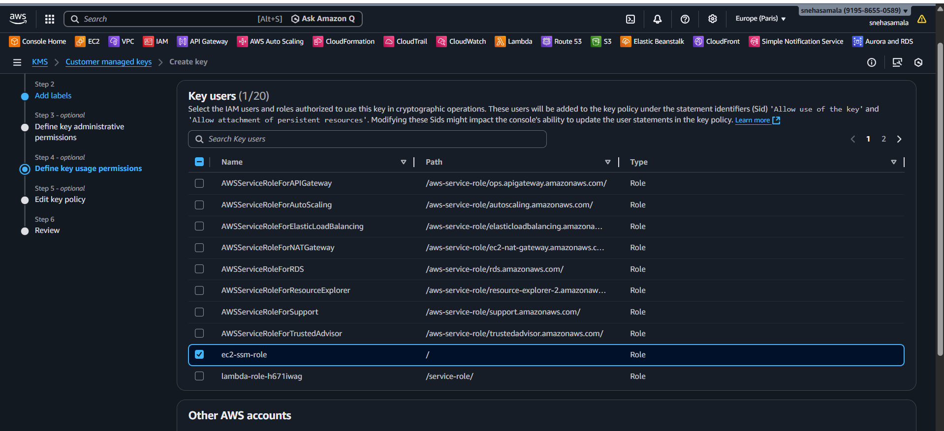
- Edit policy
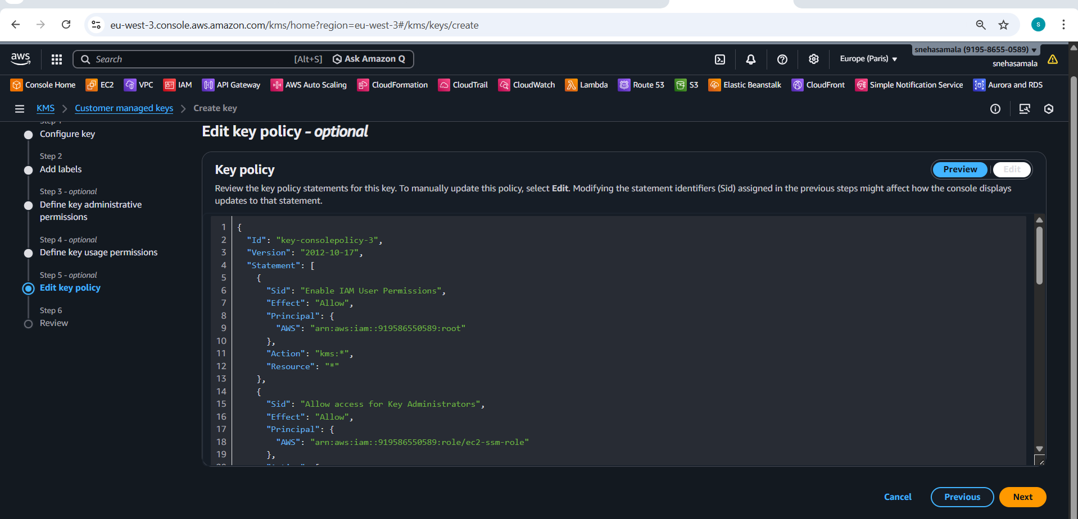
- Review finally
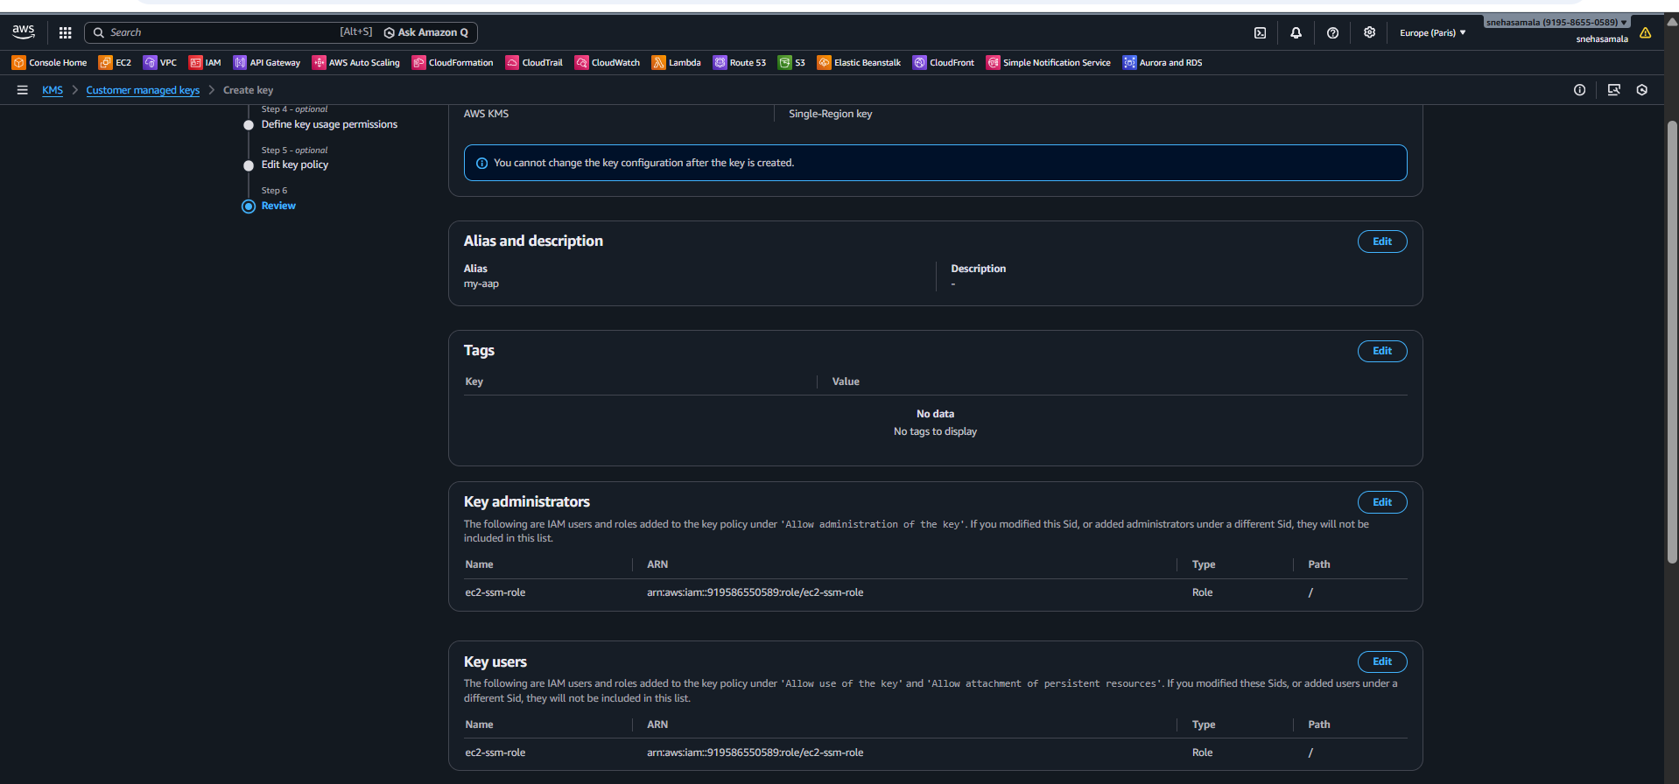
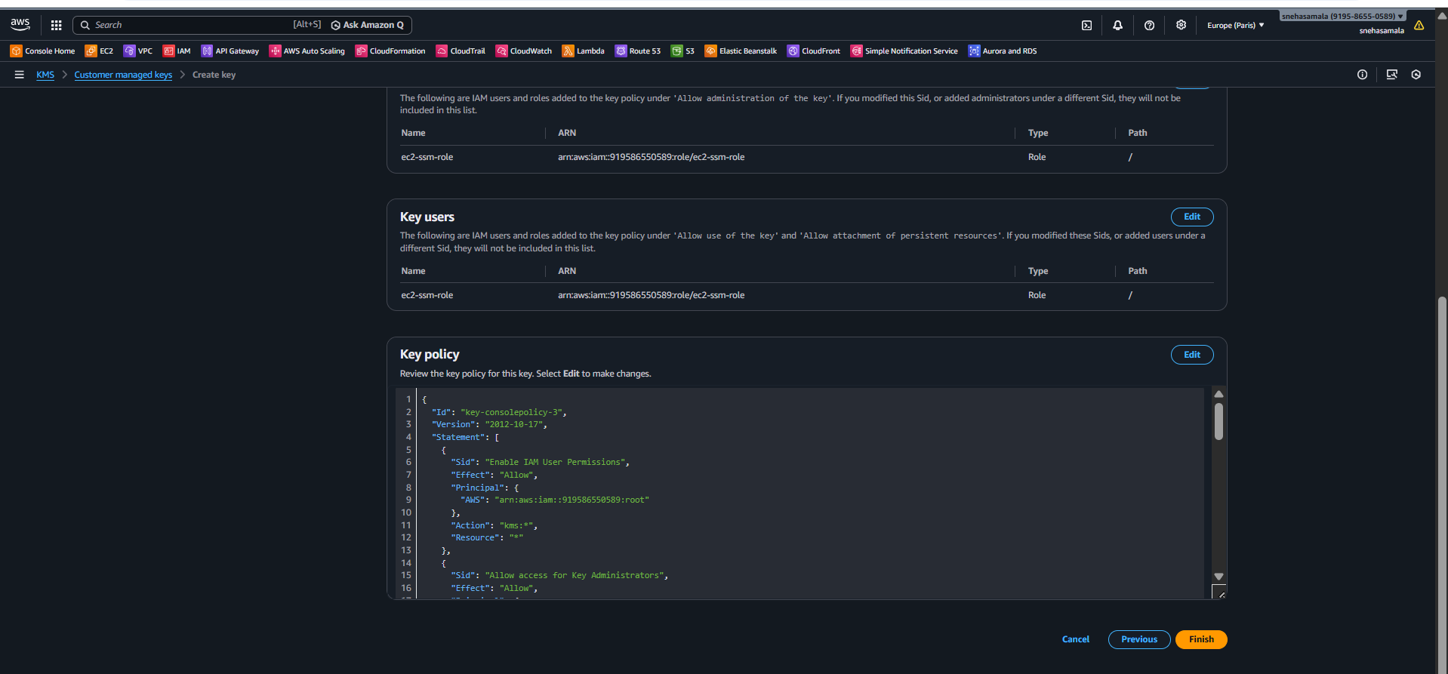
- Customer managed key is created
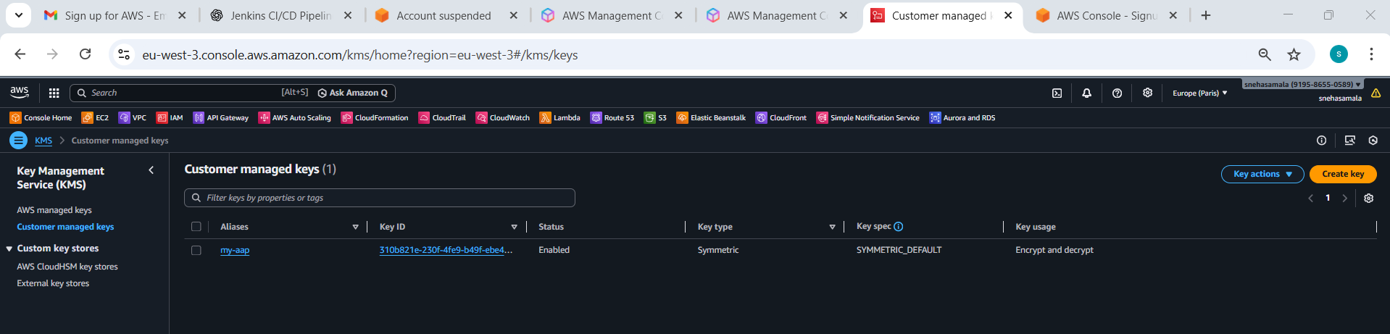

2. Using KMS Key in S3 Encryption
- Go to S3 → Bucket
- Open Properties
- Enable Default encryption
- Select AWS KMS
- Choose alias/s3-encryption-key
Upload a file
• Confirm encryption = aws:kms
- Create the s3 bucket
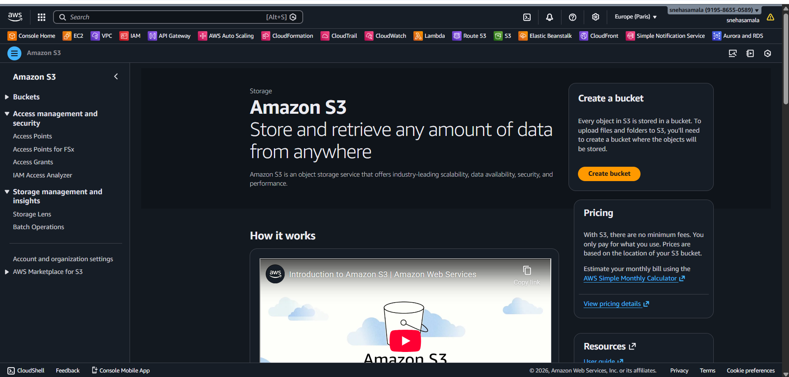
- Go to the properties
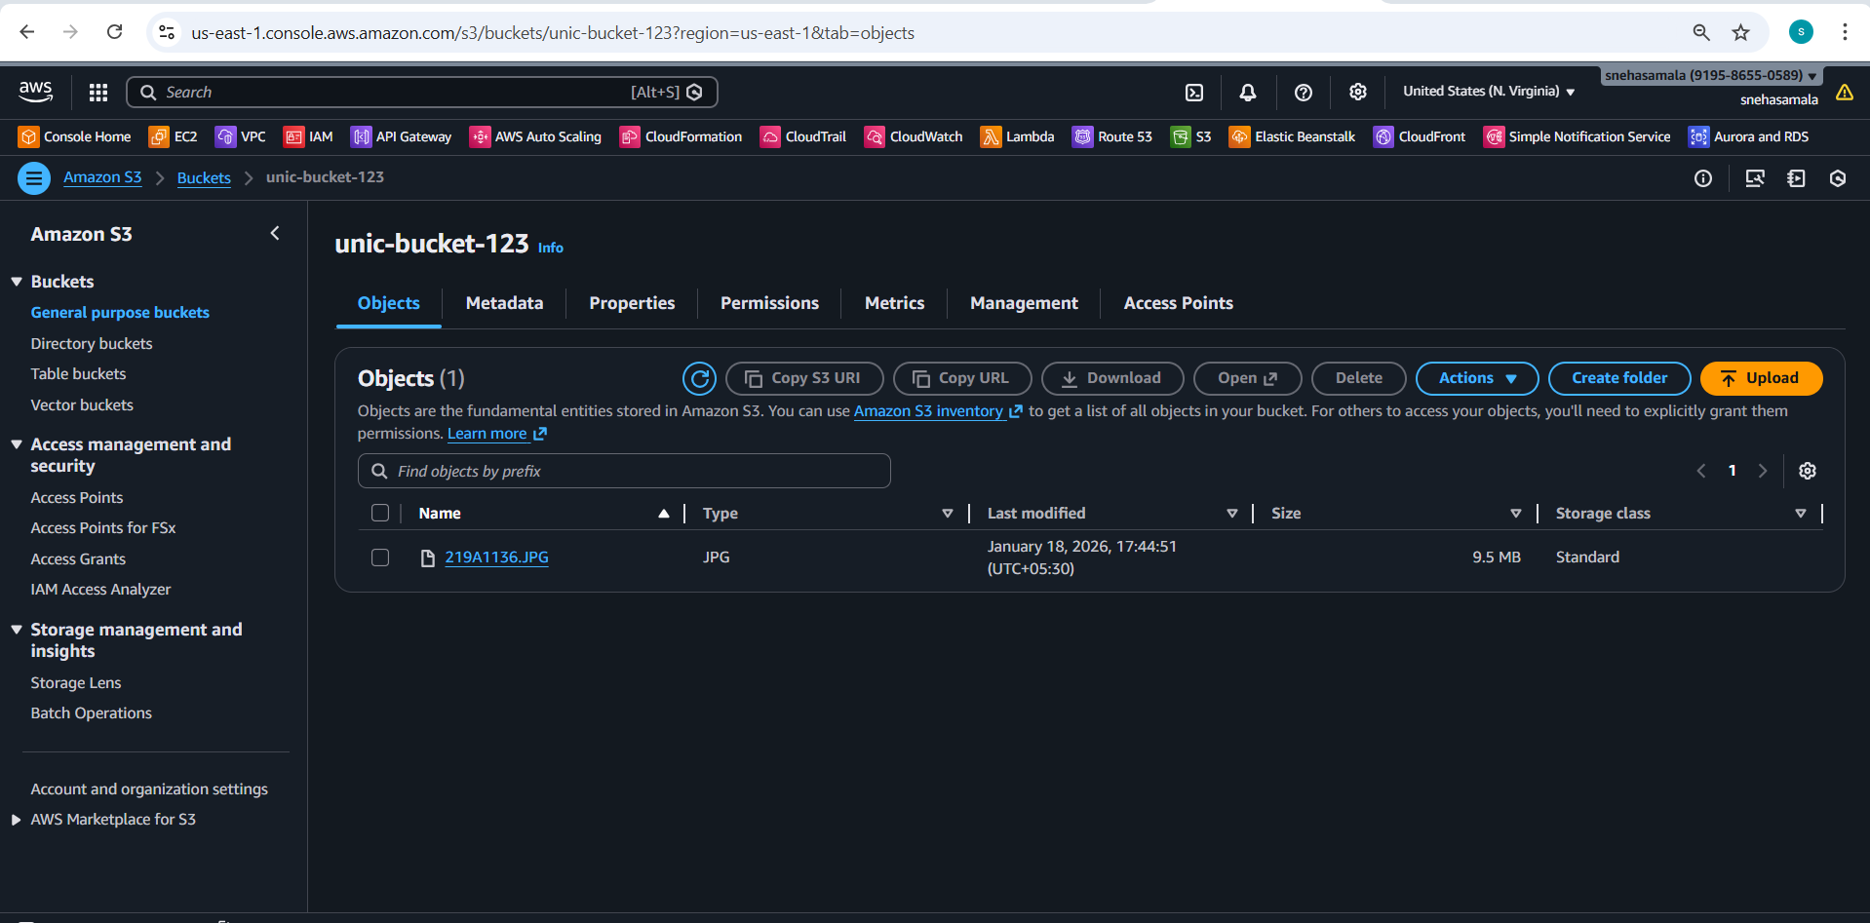

Enable S3 Encryption
- Go to S3 → Bucket
- Open Properties
- Enable Default encryption
- Select AWS KMS
- Choose alias/s3-encryption-key
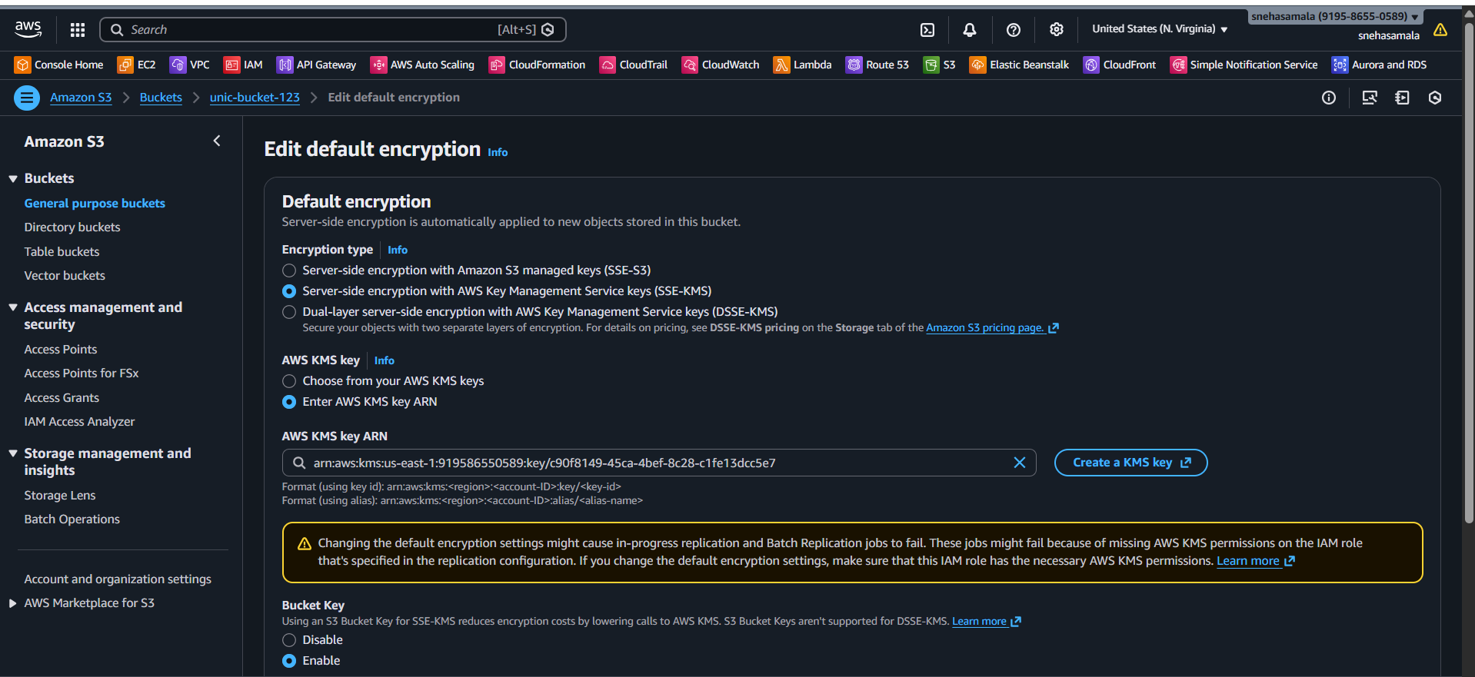
- Check the encrypting key ARN
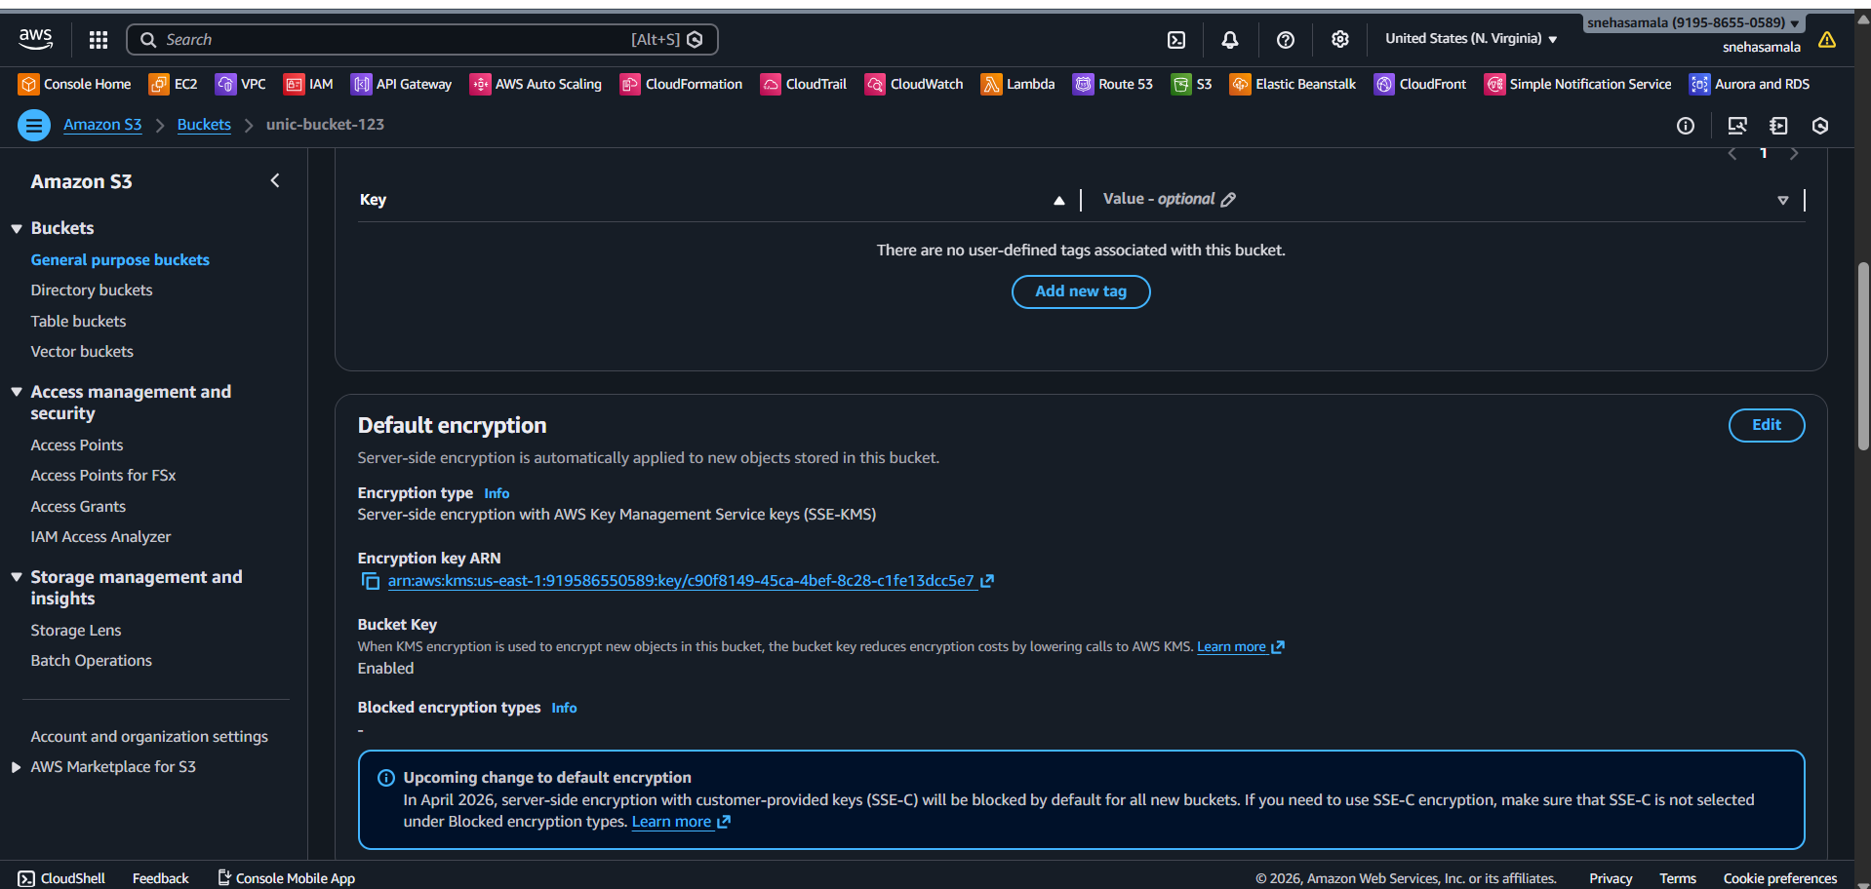

- Upload the file

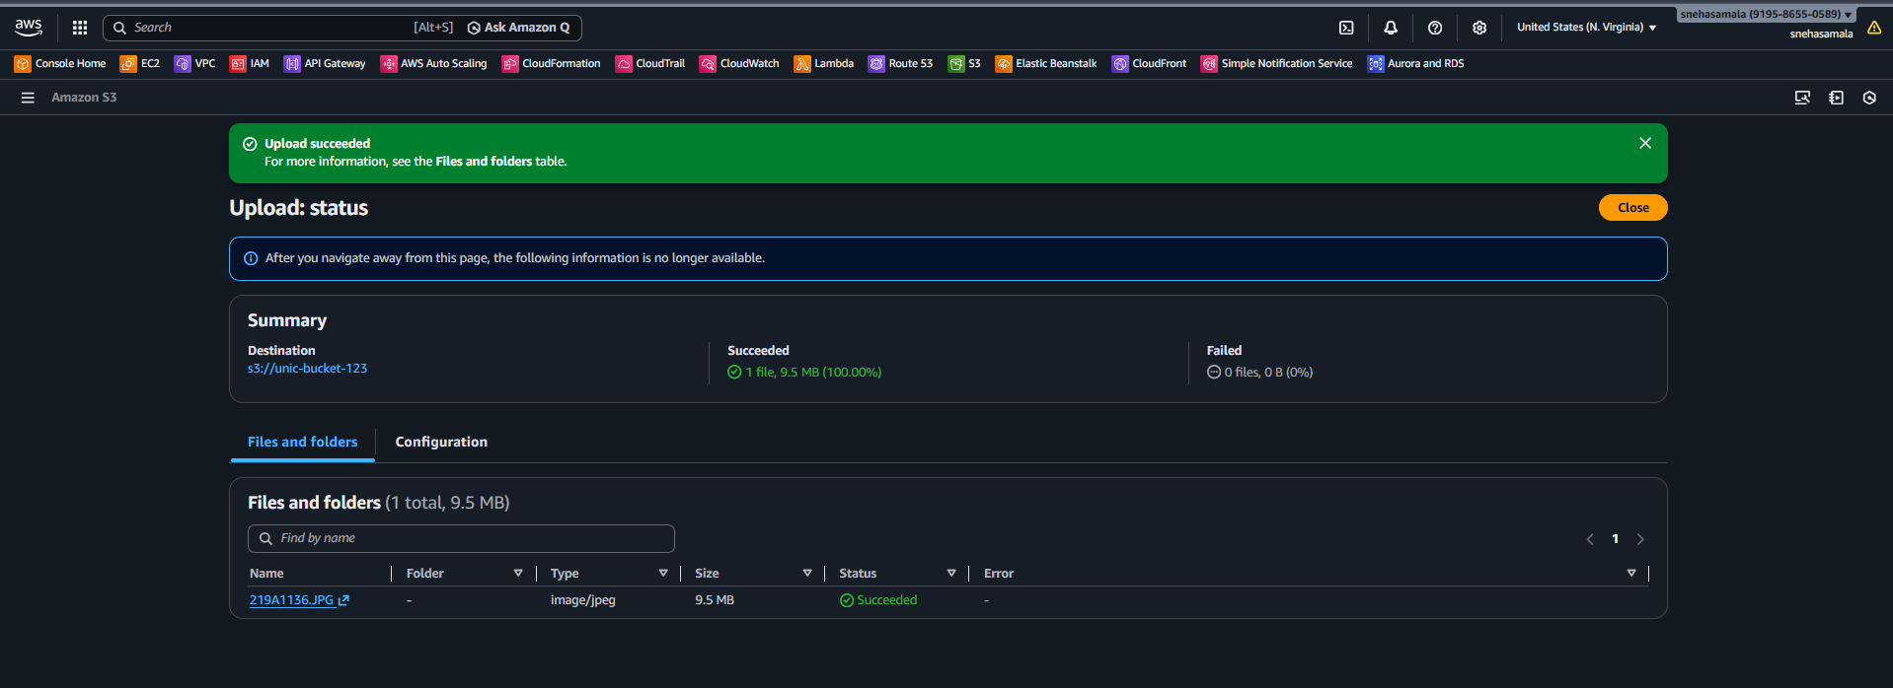
- Check volume → Encryption = Enabled
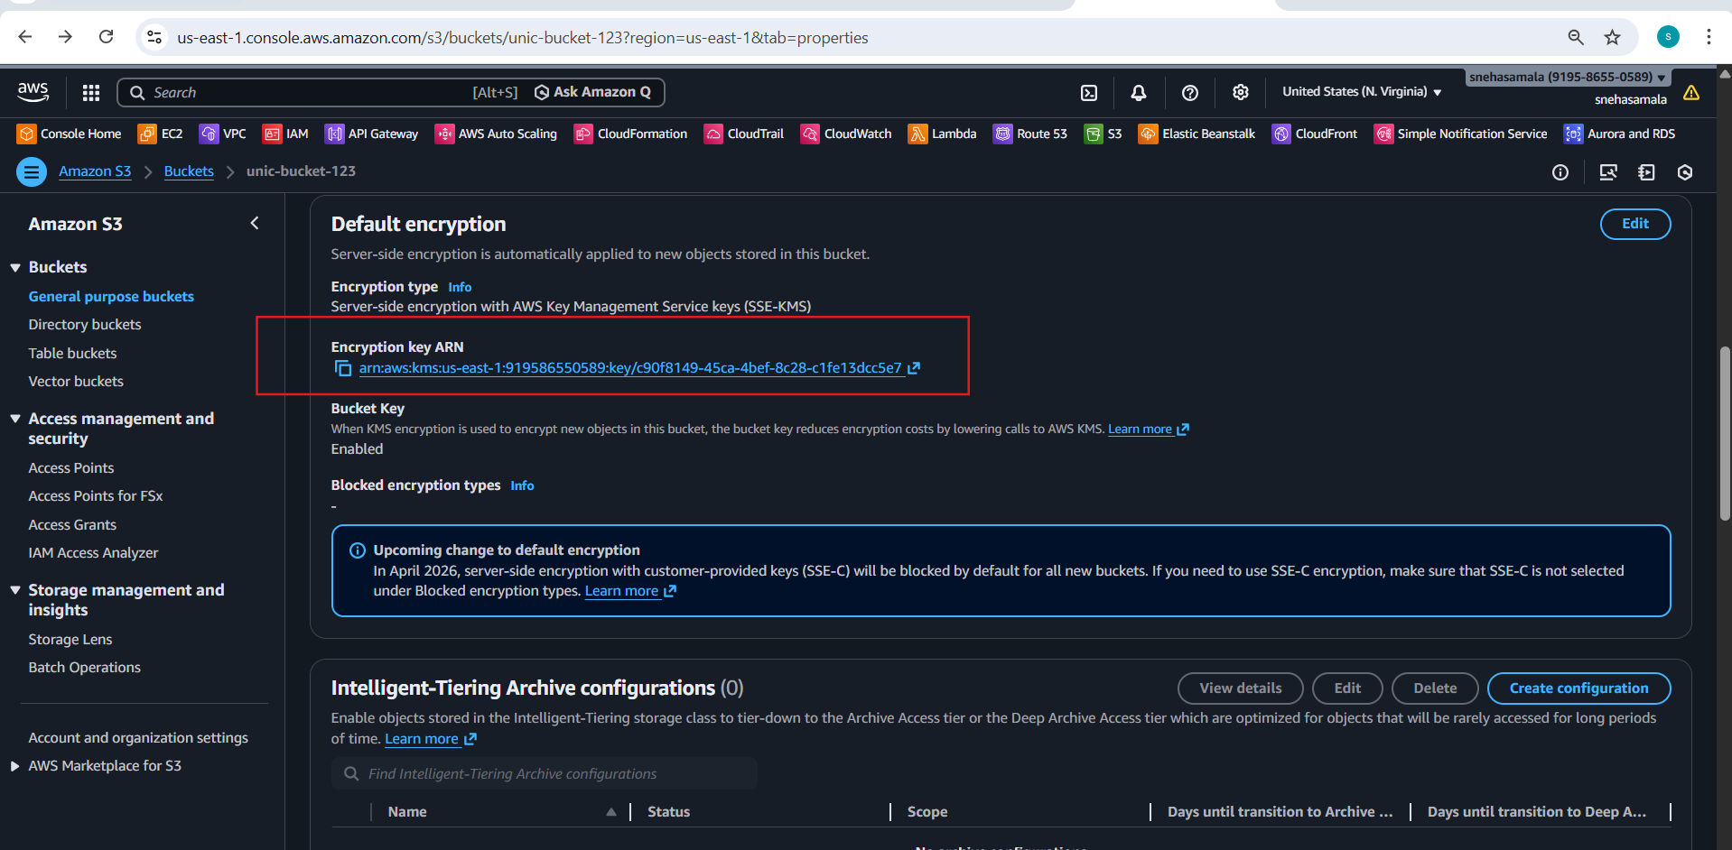
3.Create Encrypted EBS Volume
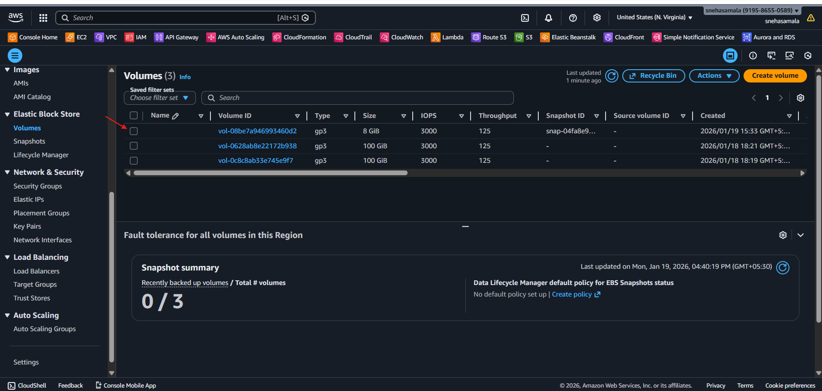
- Go to EC2 → Volumes
- Click Create volume
- Enable Encryption
- Select KMS key ebs-key
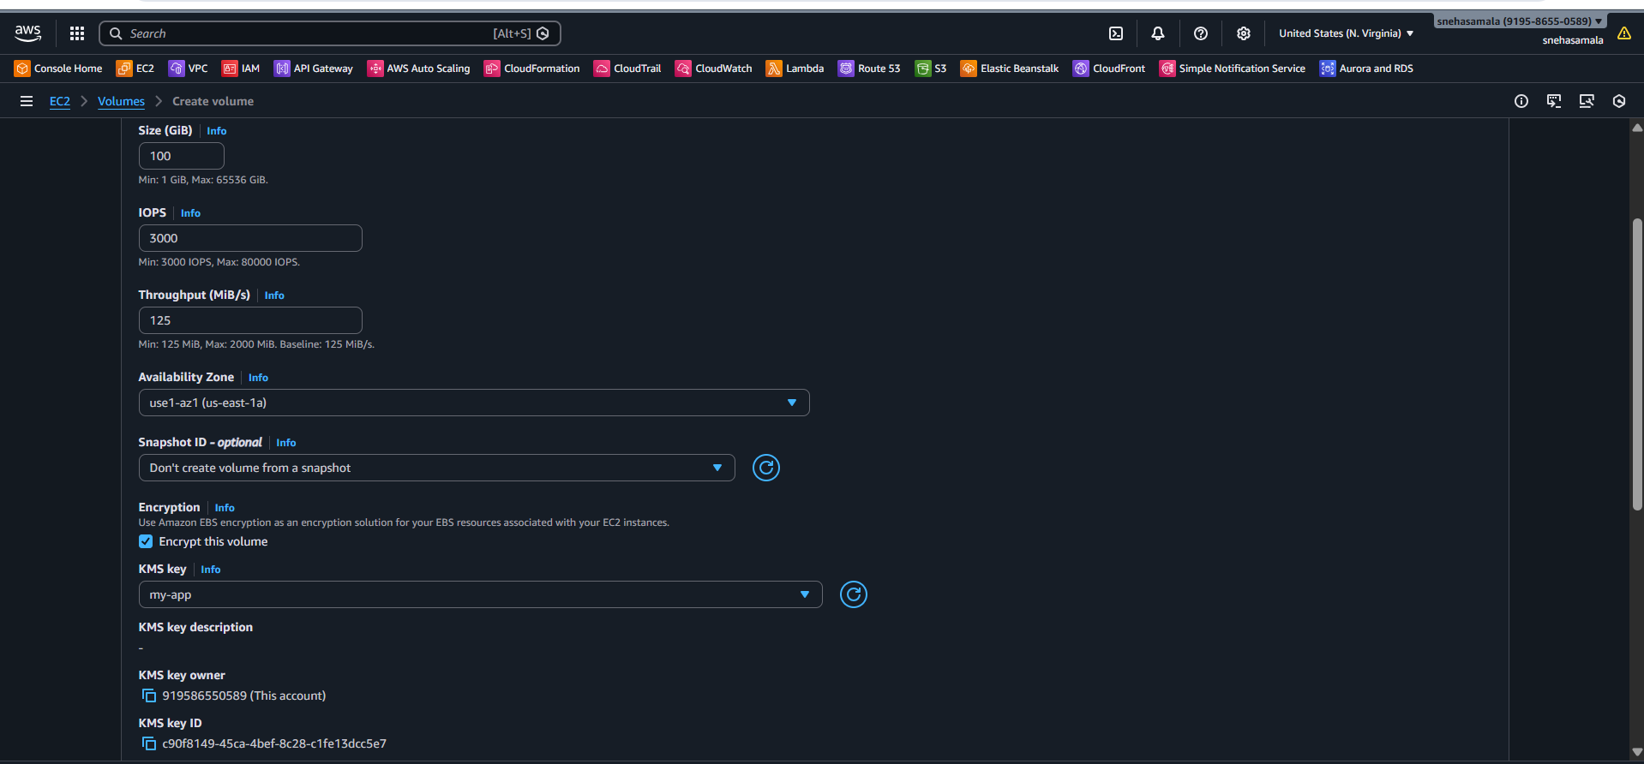
Select the volume
Actionsattachvolume
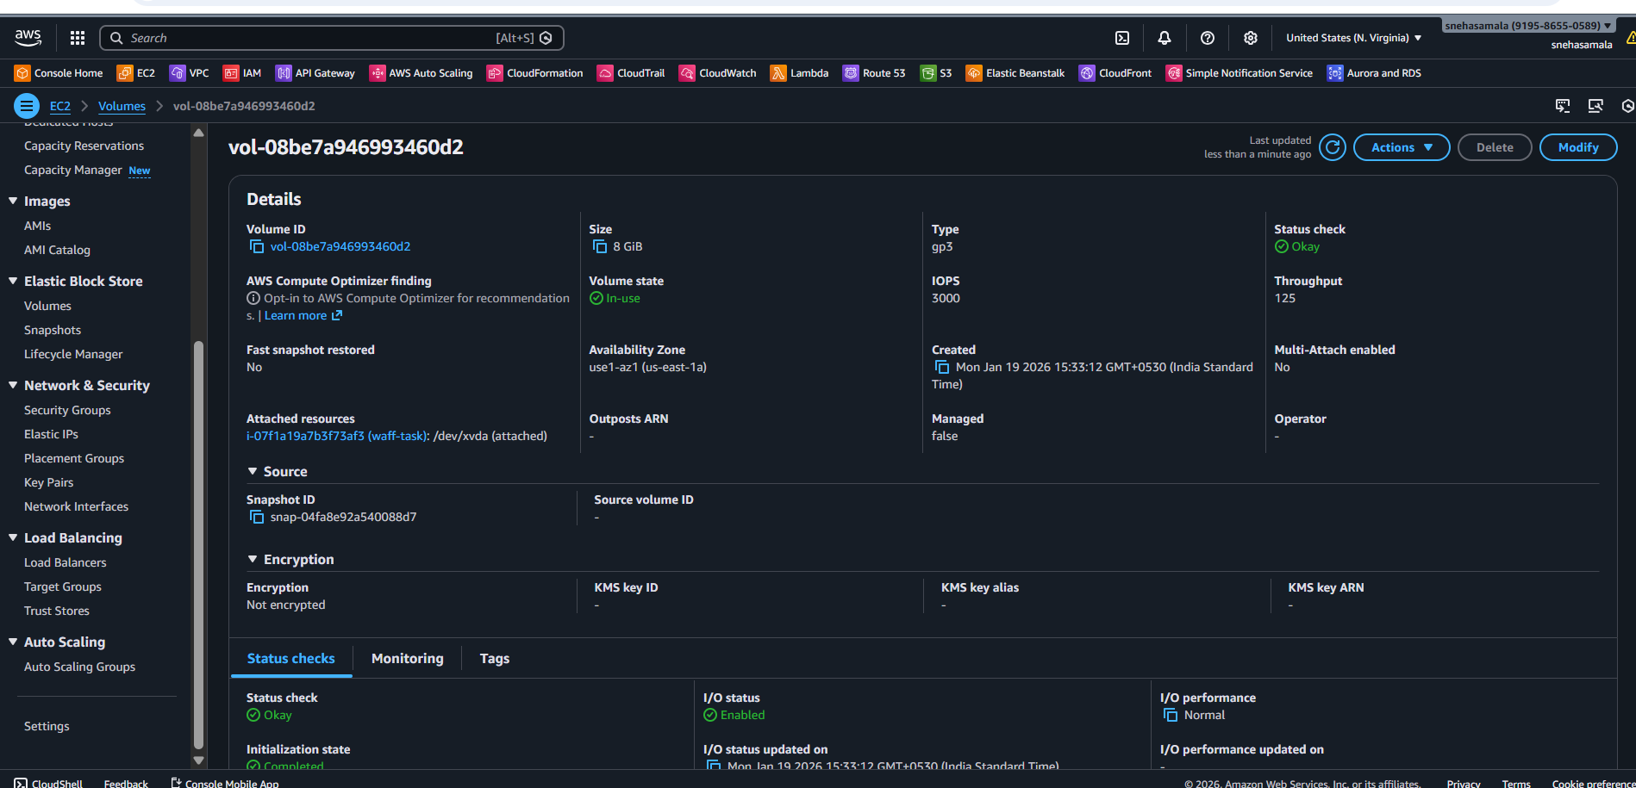
- Attach volume to EC2 instance
- Mount volume inside instance
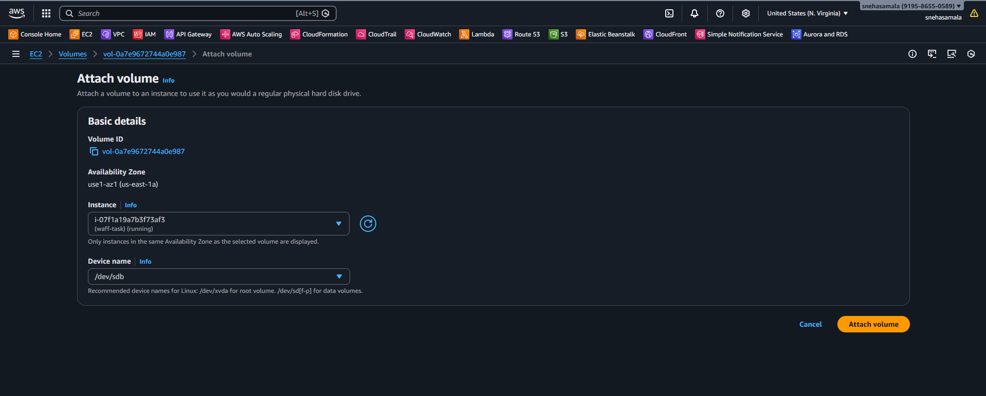
- Verify

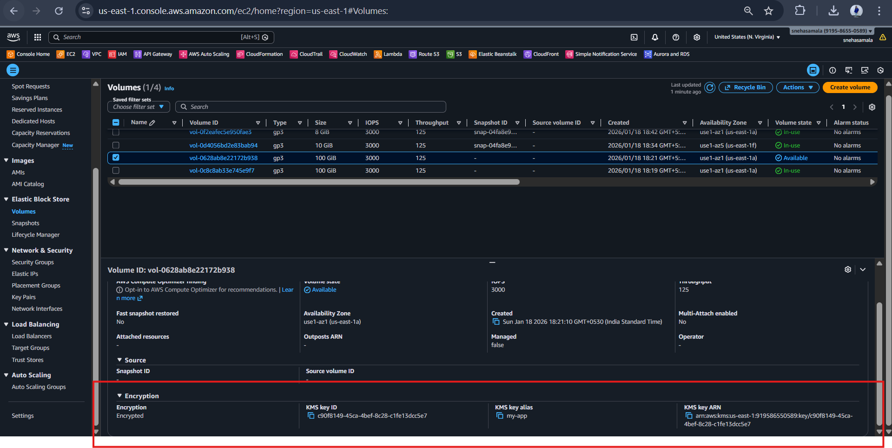

4.Encrypt Lambda Environment Variables Using KMS
Create KMS Key
• Alias: lambda-key
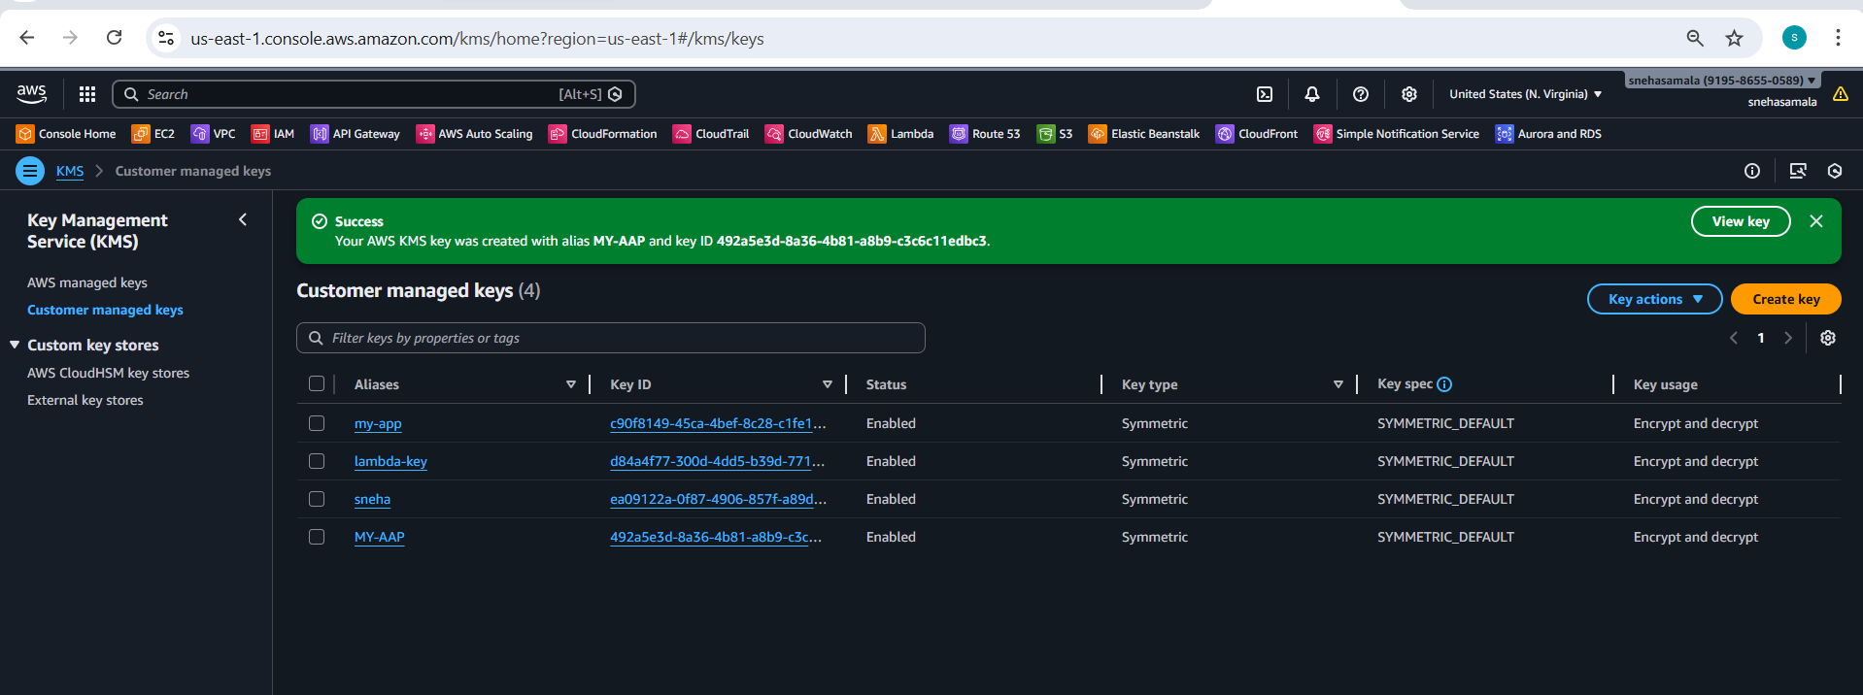
- Go to Lambda → Configuration
- Open Environment variables
- Add sensitive values (API keys)
- Choose Encryption key
- Select KMS key
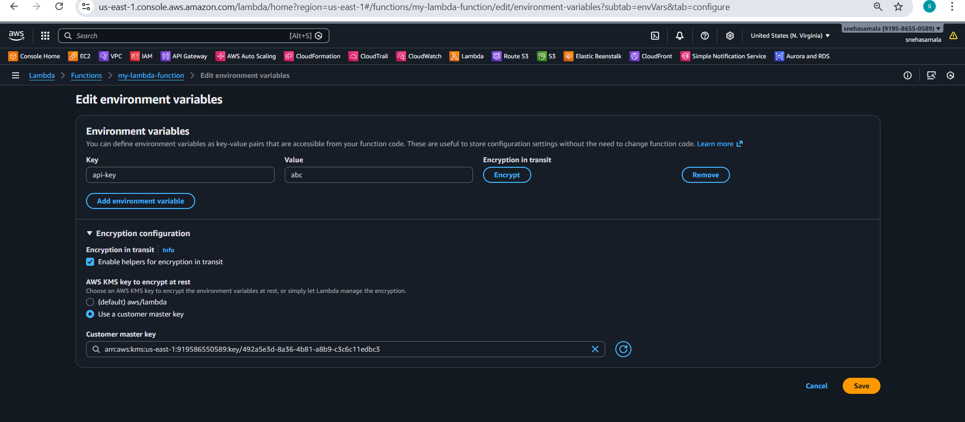
Add kms:Decrypt permission to Lambda role
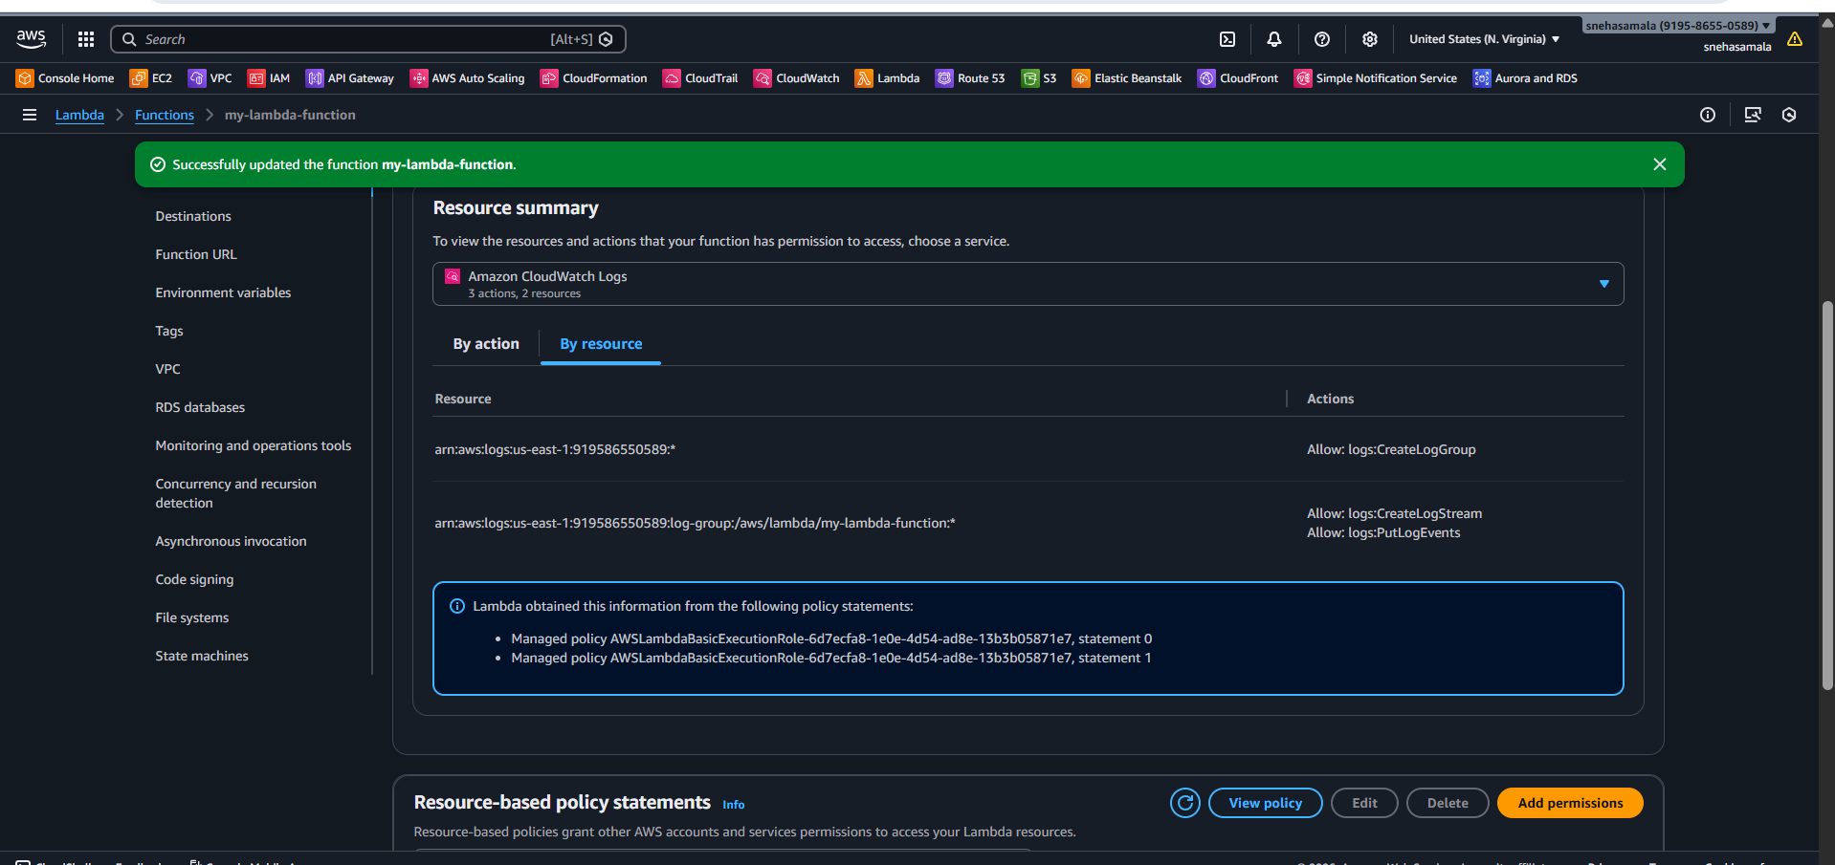
Test lambda
Ensure function executes successfully

